I just modify sheets "table 2" and "abbreviations"

-------------------------------------------------------

1 In your appendix: all your full expression should be start with the capital letter

Exp:

Wrong: "Al aluminum"

Right: "Al Aluminum"

Re: before I wrote the abbreviation, I have read the article about rule of abbreviation writing. I wrote them according to it. plz check the photos.

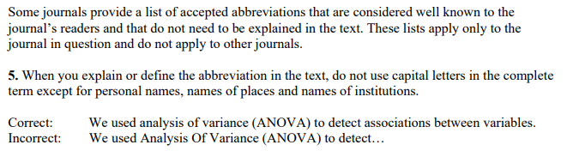

Re: This is my bad, I do not know this format requirement previously

2 About the table 2

(from other reference) ???

"(from other reference) " appears a few times in the table, what is it means?

Re: In last discussion with u before I went back, I explained about it and sent 2 other references to you. It means I've checked the experimental conditions from other references that the reference I want to describe in table referred to coz the reference I described used the condition from other reference. after ur check, I’ll delete the word “from other reference” from table.

Re: Checked, the two references do help

Col: "Applied Areas"

This column is the main reason that keeped holding me off, and i still can not find a firmed support about the classification of 'Applied Areas'. So, i just quickly the references and ur choices and then make the decision about what to fill into the blank.

Re: this is also I explained to you. it means the authors described mostly in introduction part why they used those kinds of materials in their researches coz they found their popular current use in specific areas.

Re: The purpose of columns “Applied Areas” and “Experimental Environment” is that the former col is bigger and more general range and the later col is more narrow and specific, I do not think u fully aware what to put into col “Experimental Environment”. It should not be the experiment setting in the lab used for simulation the real applied environment, like “standard glass cell” should be replaced by “petroleum pipeline”

Like row 1 and row 2, ur choices for the “Experimental Environment” are “atmospheric environment” and “aqueous chloride solution”, respectively. In fact, they use “aqueous chloride solution” in lab to simulate the practical environment “atmospheric environment”. So, We use “atmospheric environment” instead of “aqueous chloride solution”

Col: Experimental Environment

I agreed on most of ur choices

Col: Activation function

Warning: you basically enumerate all the possible activiation functions in ur table 1. So, the content in the col "Activation function" should be one of those functions. but in the references, i do find that they just use 'sigmoid' to represent their activation function, but in ur table 1, u have Logistic(sigmoidal) and Hyper tangent(sigmoidal), which is confusing to chose

Re: Both of Logistic and Hyper tangent are sigmoidal functions. I didn't change the usage of references by any of my own words. you can find it somewhere in references. sometimes, they didn't write all in one place. we need to read the whole paper. after reading the whole paper, u can catch them.

you can check sigmoidal activation function here --> https://towardsdatascience.com/activation-functions-neural-networks-1cbd9f8d91d6

Re: I do know that sigmoid contains Hyper tangent and Logistic. Hyper tangent and Logistic are certainly different, if I can make sure which one is used, I just make my decision clearer by choosing one of them instead of using confusing sigmoid.

Col: Neural network model

Warning: there are some NN containing more than one hidden layer, So, i add an Option "DNN", standing for "Deep neural network"

Re: for me, I don't want to change anything from references coz the authors used the exact name of "BPNN", "MLP", "RBF". I think they used simple multilayer backpropagation ANN with no more than 3 hidden layers. Actually, BPNN and MLP has same concept, there is no exact definition of difference between them. generally speaking, BPNN is ANN that uses backpropagation learning/training algorithm, and has one i/p layer, one hidden layer (enough for large majority of problems) or at least 2 hidden layers (for complex problems) and one o/p layer. An MLP consists of at least three layers of nodes: an input layer, one or more hidden layers and an output layer.

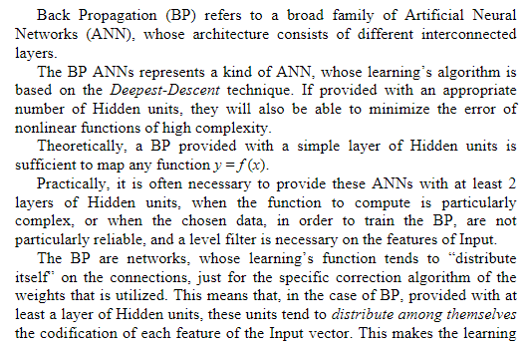

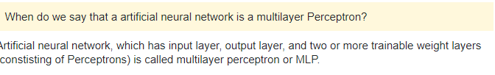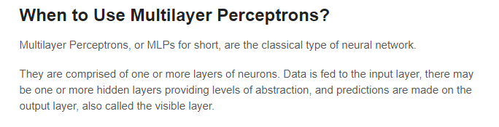

Re: According ur reply, I do not see the difference between MLP and BPNN about their number of hidden layers. In light of my own knowledge, MLP >> BPNN,

Row 12:

This reference is still very confusing for me even after several times of reading, i leave it out for now and will check it later (marked it red)

One thing i am certain is that current content in row 12 is not appropriate. There multiple kinds of amplitude loading conditions, not just the "constant amplitude loading"

Re: Yes. that point is I'm not sure about experiment. U can check from the other reference I gave you. Those conditions came from experiment of other references.

Row 22:

It is so funny that u copy few imgs to fill into the blanks rather than type it.

Re: Sorry I didn't get u. u mean R? I didn't copy them. I used equation format to write them coz they have some symbols that can’t type from keyboard. u can check my original writing in word file. it appears as copied image in Excel coz u copied and paste them in Excel. there are some options for paste function. some formats are used to change after paste.

Re: It is okay.

3 Abbreviations

I added some abbreviations that u missed (mark in blue)

Re: In Excel? I'm sorry I didn't find them.

Re: See the img below.



